1

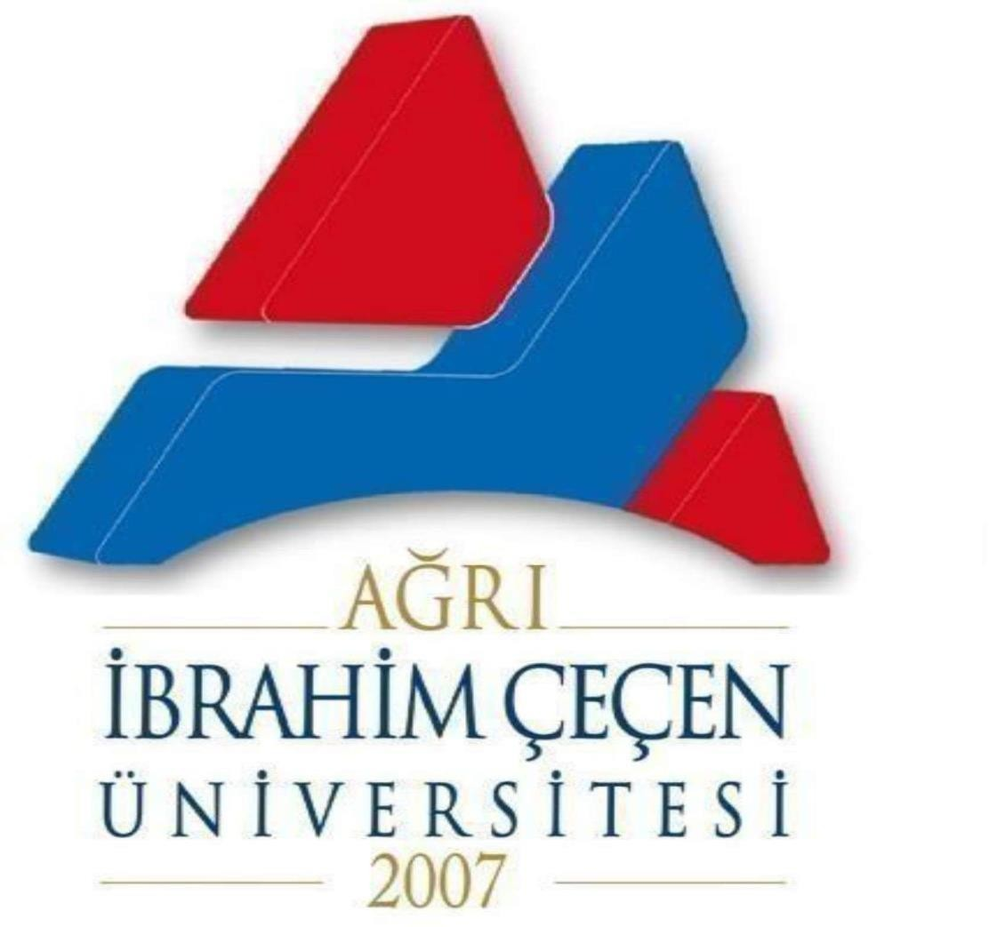

REPUBLIC OF TÜRKİYE

AĞRI İBRAHİM ÇEÇEN UNIVERSITY

2025-2026 ACADEMIC YEAR

INTERNATIONAL STUDENT ADMISSION GUIDE
Application Date | June 23 - July 25, 2025
The application Evaluation | August 4-August 6, 2025
Record Right The winners From the internet Announcement | August 11, 2024
Final Registration Date | August 11-August 22, 2025
First Reserve Registration Date | August 25-August 26, 2025
Second Backup Registration Date | August 27-August 28, 2025
Third Backup Registration Date | August 29-September 1, 2025

For more information: Ağrı İbrahim Çeçen Üniversitesi Öğrenci İşleri Daire Başkanlığı Erzurum Yolu, Rektörlük 04100 Ağrı / Türkiye

Foreign Relations Coordination: Student Affairs Department Unit
Emrullah ATASEVEN Responsible: Nalan ERBAY
Phone: Phone: 04722161010
E-Mail: ogrenci@agri.edu.tr Ext: 7003

Application Conditions

Applicants must comply with the following requirements in the Principles Regarding the Admission of Students from Abroad published by the Council of Higher Education:

Provided that they are in their final year of high school or have graduated;

1) Foreign nationals (those who study in secondary education (high school) institutions in Türkiye)
Provided that they have registered before the 2022-2023 academic year [excluding embassy schools, international private educational institutions included in the MOBIS system, and foreign nationals brought to our country within the framework of the project carried out by the Ministry of National Education]

2) If you are a Turkish citizen by birth and have permission from the Ministry of Internal Affairs to renounce your Turkish citizenship.
Those who have lost their Turkish citizenship by taking the university diploma or those who can prove that they have a blue card, which is given to those who have lost their Turkish citizenship upon request (on condition that those studying in secondary education (high school) institutions in Türkiye have registered before the 2022-2023 academic year) (Article 7 of the Turkish Citizenship Law No. 5901 states that "(1) A child born to a Turkish citizen mother or father in marriage, whether in Turkey or abroad, is a Turkish citizen." It is beneficial for candidates who will apply for admission quotas from abroad to review the Turkish Citizenship Law.)

3) Those who acquired Turkish citizenship while being a foreign national,
Those with dual nationality (those studying in secondary education (high school) institutions in Türkiye, provided that they registered before the 2022-2023 academic year)

4) A Turkish citizen who completed his/her secondary education (high school) in a foreign country other than TRNC.
Those who have completed (including those who have completed their entire secondary education [high school] in Turkish schools opened by the Ministry of National Education in a foreign country other than TRNC)

5) Those who are TRNC citizens, reside in TRNC, have completed their secondary education (high school) in TRNC and have GCEAL exam results, and those who have or will have GCEAL exam results after registering and receiving education in colleges and high schools in other countries between 2005 and 2010.

Applications are accepted.

Exams Accepted for Application

Applications are evaluated based on the TR-YÖS Turkey International Student Admission Exam and the following exams approved by the Council of Higher Education (YÖK). Quotas, minimum scores, and any special requirements proposed by individual units are determined by the Senate. New exams and admission criteria may be added to the exams listed below by Senate decision. The evaluation criteria for accepted exams are as follows:

- TR-YÖS (Turkey Foreign Student Admission Exam): Must have received at least 100 points out of 500 ,
- The Turkish Foreign Student Admission Exam (TR-YÖS) will be administered by ÖSYM starting in 2023, the first TR-YÖS will be held in January 2023, the exam will be held in Turkish, German, Arabic, French, English, and Russian, the Turkish Foreign Student Admission Exam (TR-YÖS) will be administered twice a year starting in 2024, and the TR-YÖS results will be used by all our higher education institutions in accepting students from abroad,

b) SAT I (Educational Assessment Exam): A minimum total score of 1000 and a minimum Math score of 500
c) ACT (American College Exam): A minimum score of 22 in Mathematics, Science and a total score of 22
d) GCE (General Proficiency Exam): To be at A level in at least 3 subjects, at least one of which is related to the department applied for, and to have an average grade of C or above in these subjects,
d) International Baccalaureate diploma score of at least 28 ,
e) German ABITUR exam score must be at most 4,
f) French Baccalaureate diploma grade must be at least 10,
g) A maximum of 4 Matura diploma degrees,
g) A minimum score of 70 out of 100 in the Jordanian and Palestinian Tawjihi exam,
h) Lebanese Baccalaureate grade must be at least 12,
i) Syrian Al-Shahada al-Thanawiyya (Syrian Baccalaureate): A minimum score of 150 in the score type of the program applied for,
i) Iranian high school diploma (Diploma Debirestan): Average grade point average of at least 12/20 and Piştaneşgahi graduation grade of at least 12/20,
j ) Kazakhstan National University Test: At least 50 out of 100 ,
k) People's Republic of China Gaokaonda-University Entrance Exam: A minimum score of 500 out of 750, depending on the score type of the program applied for.

Application Method

(1) Applications must be made to Ağrı İbrahim Çeçen University Student Affairs Department via our website between the dates given above.

(2) Candidates may apply to a maximum of three programs. These programs are specified by the candidates in the online Application Form.

Documents Required for Application

(1) Diploma, graduation certificate ((Atestat) photocopy)
(2) Passport (photocopy)
(3) TÖMER exam result document showing the Turkish proficiency level of non-TC citizens (if available)
Note: Originals of documents will be requested during registration.

Documents Required for Registration

(1) The original of the diploma (Atestat) “graduation certificate or Atestat must be certified by the consulate or apostilled”
(2) Diploma equivalence certificate (obtained from consulates, provincial directorates of national education)
(3) Original passport and Turkish translation (notarized)
(4) Turkish translation of the transcript (notarized)
(5) Entry and exit documents of Turkish citizens abroad
(6) TÖMER certificate for those who are not Turkish citizens
(7) 6 photographs

Documents Required for Residence

(1) Residence permit
(2) General health insurance
(3) Tax and duty fee
(4) Passport photocopy and Turkish translation
(5) Address document and the last bill sent to this address (electricity, natural gas, water, etc.)
(6) Active student certificate
(7) Criminal record
(8) 4 biometric photographs

Tuition Fees: The Decision on the Determination of Fees to be Collected as Student Contribution to Current Service Costs in Higher Education Institutions in the 2025-2026 Academic Year Will Be Updated in Accordance with the Presidential Decree

 | INTERNATIONAL STUDENTS
 | Students who registered in the 2021-2022 academic year and later
FACULTY/COLLEGE | FORMAL EDUCATION | SECONDARY EDUCATION
YEAR AND SEMESTER | 2023-2024 Fall | 2023-2024 Spring
Faculty of Medicine | 41410.00 | 41410.00
Faculty of Pharmacy | 14950.00 | 14950.00
Faculty of Education | 5500.00 | 5500.00
Faculty of Arts and Sciences (Literature and Social Program) | 5140.00 | 5140.00
Faculty of Arts and Sciences (Science Program) | 6850.00 | 6850.00
Faculty of Economics and Administrative Sciences | 6200.00 | 6200.00
Faculty of Islamic Sciences | 5500.00 | 5500.00
Faculty of Islamic Sciences ARABIC | 5500.00 | 5500.00
Faculty of Sports Sciences | 5500.00 | 5500.00
Faculty of Health Sciences | 5500.00 | 5500.00
School of Foreign Languages | 6200.00 | 6200.00
School of Tourism and Hotel Management | 6200.00 | 6200.00
Celal Oruç Animal Products College | 6200.00 | 6200.00
Patnos School of Social Services | 6200.00 | 6200.00
Vocational School | 4100.00 | 4100.00
Vocational School of Health Services | 4100.00 | 4100.00
Civil Aviation Vocational School | 4100.00 | 4100.00
Patnos Vocational School | 4100.00 | 4100.00
Eleskirt Vocational School | 4100.00 | 4100.00
Doğubeyazıt Ahmed-i Hani Vocational School | 4100.00 | 4100.00
Institute of Graduate Education | 4100.00 | 4100.00

Students can deposit their tuition fee into our University's corporate collection account from all branches and ATMs of Halk Bank during course registration.
Halk Bank Ağrı Branch IBAN number TR 5600 0120 0917 3000 0600 0206

IMPORTANT WARNING

2025-2026

If the required documents for registration specified in the academic year foreign student application guide are missing, registration will not be carried out.

